**Ideation Phase**

**Brainstorm & Idea Prioritization Template**

|  |  |
| --- | --- |
| Date | 15 June 2025 |
| Team ID | LTVIP2025TMID20285 |
| Project Name | TrafficTelligence: Advanced Traffic Volume Estimation with Machine Learning |
| Maximum Marks | 4 Marks |

**Brainstorm & Idea Prioritization Template:**

Brainstorming provides a free and open environment that encourages everyone within a team to participate in the creative thinking process that leads to problem solving. Prioritizing volume over value, out-of-the-box ideas are welcome and built upon, and all participants are encouraged to collaborate, helping each other develop a rich amount of creative solutions.

Use this

Reference: <https://www.mural.co/templates/brainstorm-and-idea-prioritization>

**Step-1: Team Gathering, Collaboration and Select the Problem Statement**

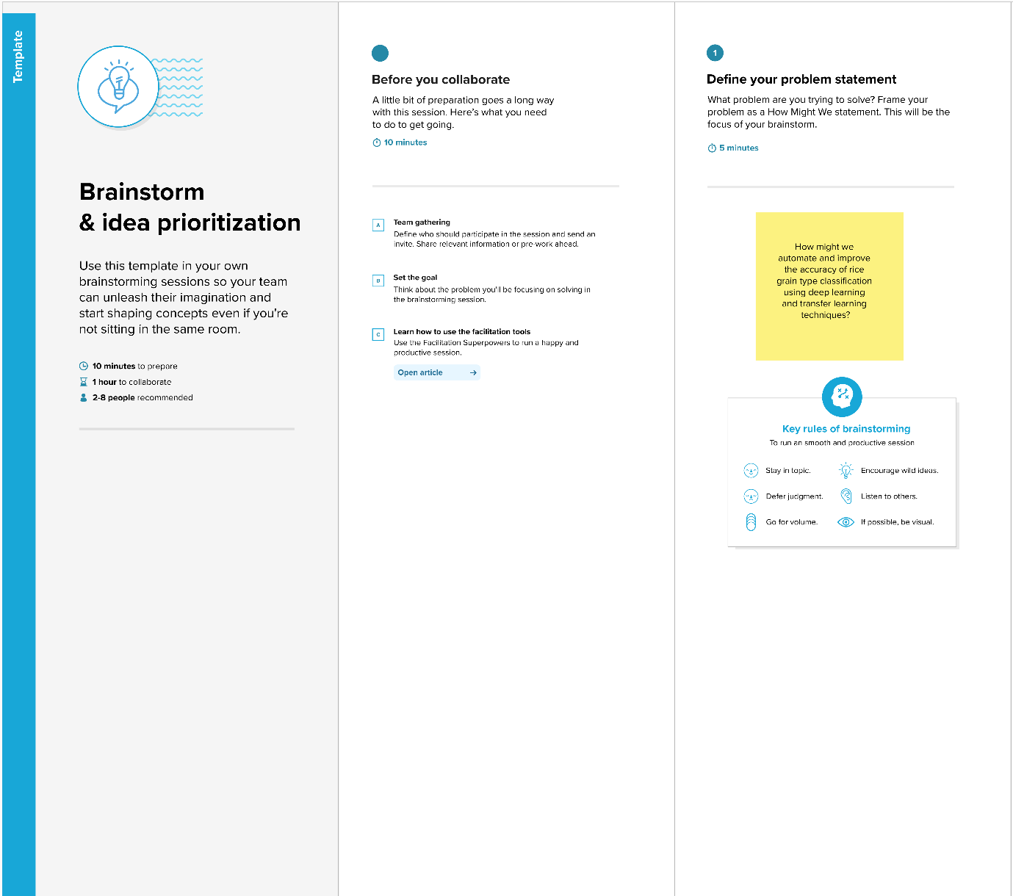

**Step-2: Brainstorm, Idea Listing and Grouping**

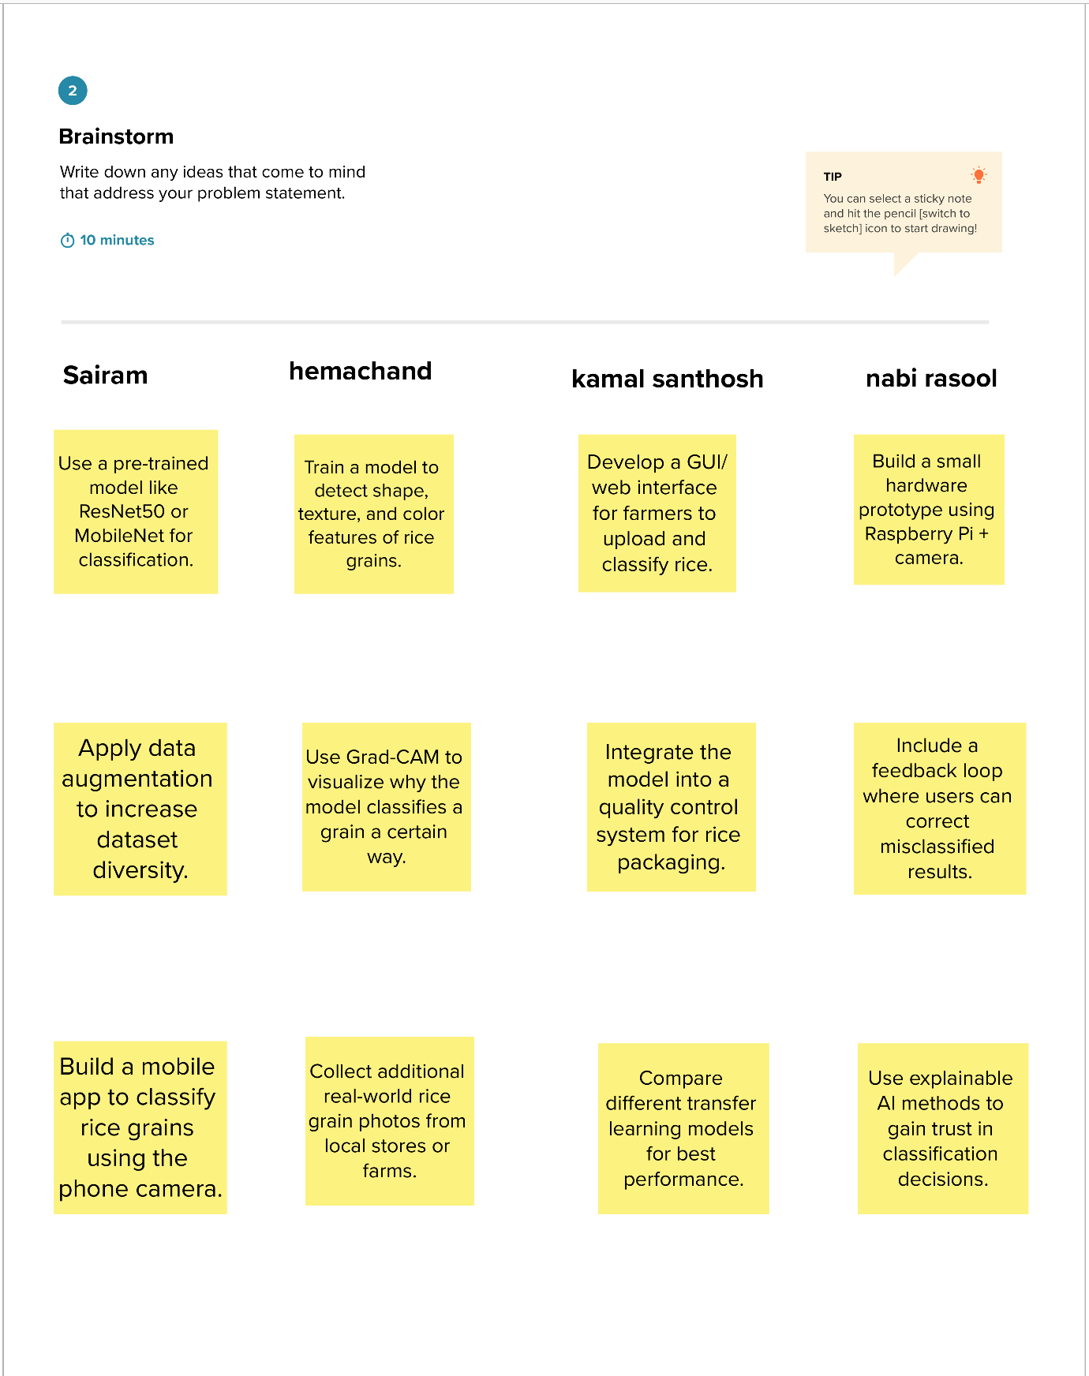

**Step-3: Idea Prioritization**

